*SONI COMPUTER CLASSES*
- How To Break Windows XP Password.?
*Solution*

Did you forgot your password
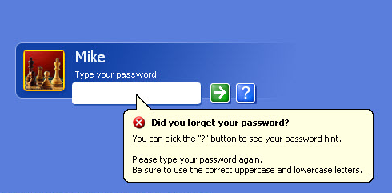
1st Press Alt+Ctrl+Del
Aap k Screen Pe kuch is tarik ka aa raha h
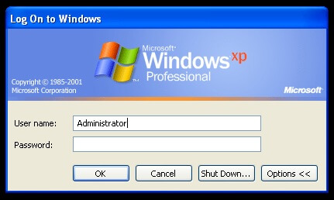
& Then Type Administrator Then Enter/Ok


Aap Window pe login ho jaoge.

Go to User Account & Select the User.
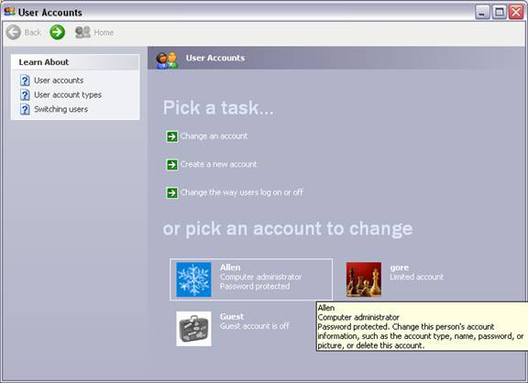
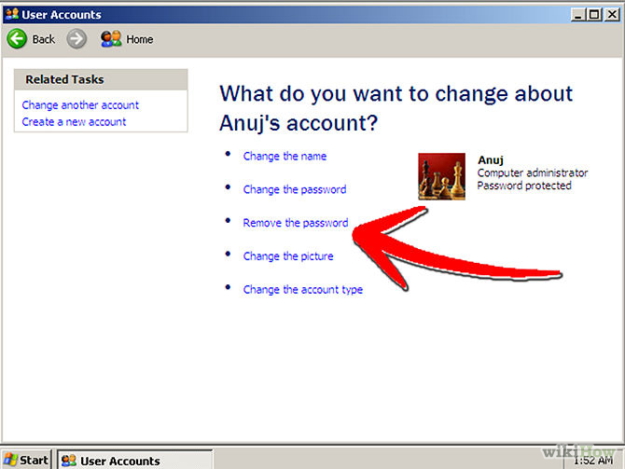
Name : Ravi Kant Soni.
Contactno : +918269000074
Address : H no. 248 Ram Sagar Para Darri Road Korba Chhattisgarh.
Like facebook page : https://www.facebook.com/sonicomputerclasses
Thank all Of you.

At last Restart Your System (P.C).

Remove the Password.

